# Chapter 1: Introduction

## Chapter Overview

This chapter covers the overview of the project, it’s background, the justification of the problem being addressed and the research question relevant to this research. The motivation behind attempting this research is also explained. Furthermore, the Aim and the scope that will be attempted in this research will also be defined. The Research objectives that will be fulfilled and also personal objectives of conducting this research will be mentioned along with an overview of the solution. The requirements for such proposed solution will also be defined.

## Project Overview

### Project Background

**Images**Human beings can be considered predominantly visual creatures as we use our sense of vision when available to understand our surroundings. Due to this reason we have created images to capture moments of this ever constantly moving world. Images have since then evolved to not only capturing real world moments but to digital drawings and other representations of visual still media. An image can be a single picture which represents something. It may be a picture of a person, of people or animals, or of an outdoor scene, or a microphotograph of an electronic component, or the result of medical imaging. When image files are attempted to be classified, two main classifications can be identified. Vector images and Raster images. There are different pros and cons of using either a Vector image or a Raster image.

**Raster Images**

A raster image is built up of color pixels which are arranged to form the necessary result image.Raster images are mostly suited for linear art images because they can better represent subtle chromatic gradients due to the fact that each pixel can change its value independently of other pixels to form the necessary image. These types of images are also called continuous tone images.

A raster image while being faster to process and display as there is no methodical processing or such involved will have a larger file size as information is electronically stored on a pixel-by-pixel basis (Winnemoeller *et al.*, 2018), the size of the image is directly proportional to the resolution of the image

**Vector Images**Vector images on the other hand are created from points and lines and curves joining them. These are based off of mathematical formulas that create combinations of multiple true geometric primitives to create a final image (Seel-audom, Naiyapo and Chouvatut, 2017)..

Vector format based computer graphics tools have become very powerful tools allowing artists, designers etc. to mimic many artistic styles, exploit automated techniques, etc. and across different simulated physical media and digital media (SEVERENUK *et al.*, 2019). Similarly, in real world applications according to the factors that need to be considered, the image may be required in either Raster or in Vector format.

As stated above, as a vector file and raster file of the same image may have similar resulting image, when observed on a deeper level multiple differences can be identified between them.

### Problem Domain

Geographic Information System (GIS) is the processes of managing, manipulating, analyzing, updating and presenting metadata according to its geographic location, to be effectively used in different aspects of life (Al-Bayari, 2018). The proliferation of GIS technology has greatly increased the access to and the usage of spatial data. Making maps is relatively easy even for those who do not have much cartographic training (Wong and Wu, 1996).

According to the analysis needed to be performed on a certain image obtained, the requirement for a Raster image or a Vector image may vary. There are several pros and cons when you consider each type of image. There is an old GIS adage stating that “Raster is Faster but Vector is Corrector”.(Berry, 1995).

Vector GIS results in the geometrization of the geographical world, and generalizing and reducing its theory into theories about relations between points, lines, polygons and areas. Such objects which are in a GIS can be counted, moved about, stacked, rotated labelled, cut etc. and be handled like a variety of other everyday solid objects that bear no particular relationship to geography (Couclelis, 1992).

Vector maps use simple geometric components such as points, lines and polygons in adjacencies, unions and inclusions to describe spatial information and Raster maps are based on pixel matrices and are richer and realistic than vector maps (Lin and Guo, 2011).

There are several advantages of using a Vector data format. These can be stated as the output being more aesthetically pleasing and zoom able to very close detail as it is made up of points and line segments connecting them and not using fixed number of pixels which might look pixelated and less clear when zoomed into more than its resolution allows. It also provides higher geographical accuracy due the same reason as it being not of a fixed resolution. There are other reasons as why vector images are used in GIS such as data integrity, and allowing network analysis and proximity operations as they both use vector data structures. As well as there are advantages are there are disadvantages to using vector images as well. As these images are a result of mathematical calculations it is often very processing intensive. Vector data structures are also poor performing when displaying continuous data, and needs to be generalized in some manner to display, which can result in loss of some information.

While vector data structures in GIS over determines the geographic world by forcing it into a geometric objects generalizing them, the raster data structure feigns maximal ignorance on the nature of things in the world. Yet Raster data structures provide an implicit view of the geographical world with measurable values discretized into pixel arrays (Couclelis, 1992).

Raster data can store unique values per each pixel without any generalization being required. Therefore, is a good option when continuous data is required to be displayed. Even though continuous data can be very accurately represented in a Raster image, because of the resolution. Raster graphics display devices are capable of reproducing very complex images (Sloan and Tanimoto, 1979). It struggles when representing linear features and can cause pixilation if the resolution of the image obtained is low or when zoomed to obtain a closer look. Raster datasets can also be very large file as when the resolution is increased to get a more accurate image with high detail the file size increases proportionally with it.

As we can see from the statements above, we can identify that both these formats are equally important when considering the use of imagery in GI Systems. Therefore there becomes necessary a method of conversion between these two data types.

### Problem Justification

Automated conversion of engineering drawings and such similar content into Raster and vector data has been a very widely discussed topic. A critical step in this process can be considered as the conversion of these images into a vector format (Liu and Josep Lladós (Eds.), 2005). Many techniques for conversion of raster to vector have been proposed which has even led to development of commercial solutions to tackle this issue. The systems created all did provide quite acceptable results but each had their own drawbacks (Hilaire and Tombre, 2006). (Lacroix, 2009)

### Research Question

How is the problem of a common platform that identifies the properties of a Raster image and converts it into a Vector file by using the best method of conversion using parameters which best fit the use case of the resulting vector image addressed currently in the research domain of GIS graphics processing?

### Motivation

After researching on the basic concept of converting Raster images into Vector images for graphic design purposes, I have come to find the importance of it but in a different domain which is in the field of GIS. Raster and Vector data structures are widely used in analysis in GIS and as both of these type of images are needed according to different situations. It has motivated me to create this automated Raster to Vector conversion tool.

## Project Aim and Scope

### Project Aim

To investigate design and implement a Raster to Vector conversion platform that selects the best method of conversion using image processing techniques.

### Project Scope

**In-Scope**

* Raster to Vector conversion tool is only developed geared towards GIS
* Training an image processing model to identify certain properties of images that affect conversion algorithms.
* Integrating Image processing for the identification special characteristics to identify the best conversion algorithm
* Considering of continuous tone images as well as line based images for the conversion process
* Set conversion method from either one of Accurate or Fast conversion

**Out-Scope**

* Conversion of Raster to Vector for other domains such as graphic design.
* OCR functionality out of image text is not considered, and will be represented in the converted images as graphical data and not textual data.

## Objectives

I have identified the following as the objectives to achieve to complete my Research successfully.

### Research Objectives

* To conduct a thorough literature review on existing solutions and platforms
* To design an image processing model to identify properties of a Raster image.
* To implement functionality to determine the most favorable algorithm for the conversion through the parameters identified from the image processing process.
* To evaluate the converted Vector image in terms of accuracy and speed of conversion.

## Overview of the Solution

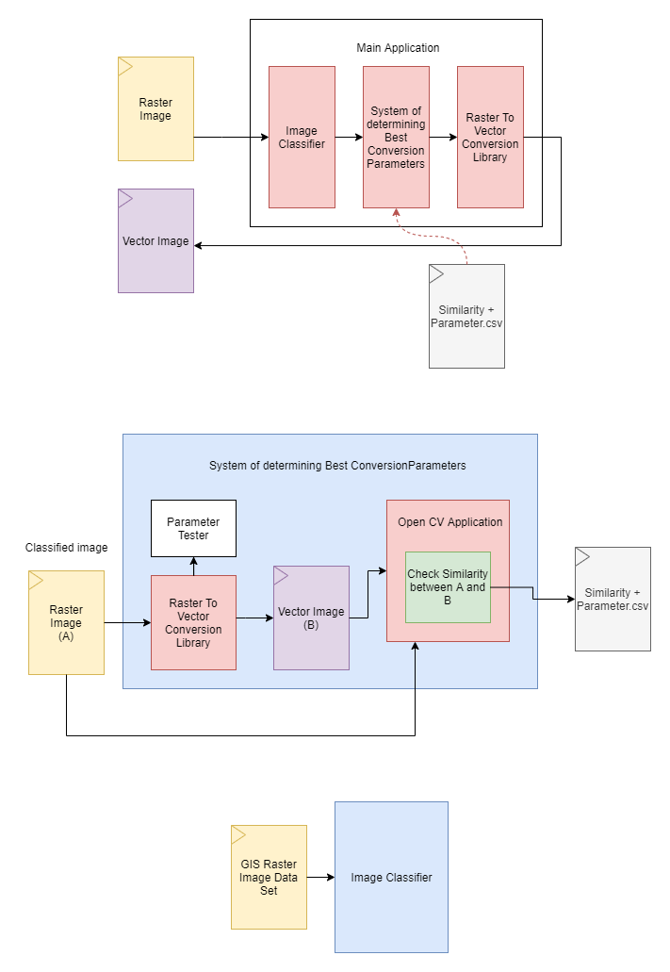

As shown in the figure above the main system is made up of three components. The image classifier, system of determining best conversion parameters and the raster to vector conversion library.

When taking a closer look at each system; the system of determining best conversion parameters is a machine learning based system that finds the best conversion parameters by interpolating data from a set of previously identified conversion parameters for each image classification and the match rate of the image to its particular classification determined by the Image classifier.

The initial best fit parameters are identified by converting a single image into multiple vector images each time with different parameters within a certain range of each parameter and comparing its visual similarity with the original using an image processing library. This similarity is then recorded in a csv file for the system of determining the best conversion parameter to use.

A data set of several hundred labelled GIS image types are used to train the image classifier.

The raster to vector conversion library is used to convert the images from its raster to vector format in each step that its necessary to do so.

These three main components make up the main system and together convert any given GIS based image which can be classified into an accurate vector image.

## Resource Requirements

*Note these requirements can be subjected to change

#### Software Requirements

* **Windows 10 (64-bit version):** To accommodate and run the software
* **Java, Python:** For the conversion algorithms to function
* **NodeJS:** For backend related scripting
* **MSWord:** For documentation Requirements
* **GraalVM:** For cross platform application support

#### Hardware Requirements

* Core i7 Processor
  + High processing power required for algorithms to be executed
* Minimum 4GB RAM
  + For application to run smoothly and not run out of system memory
* Disk Space: Up to 10GB
  + For storing of application and images and temporary files created while converting and running algorithms

## Chapter Summary

Have to write